# Final Exam

1. C# provides us with a Stack<int> generic template to create a stack of integers. Write your own MyStack class in a console app that contains a List<int> and implements the three Stack methods: Push(int n), Pop() and Peek() using the List<int>. You may not use Stack<int> in your solution.

GitHub URL:

1. Modify the console app in #1 to create your own MyQueue class that contains a List<int> and implements the three Queue methods: Enqueue(int n), Dequeue() and Peek() using the List<int>. You may not use Queue<int> in your solution.

GitHub URL:

1. Create a console application and represent the following digraph as an adjacency matrix and an adjacency list:

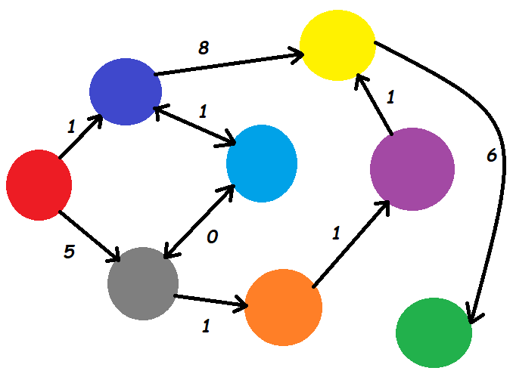

GitHub URL:

1. Using the console application created in #3, Implement a Depth First Search of this digraph starting from red and output the colors.

GitHub URL:

1. Using the console application created in #3, implement Dijkstra's shortest path algorithm to output the shortest path of colors from red to green.

GitHub URL:

1. Create a console application which defines and uses a singleton class which includes methods to load and save the player's settings using the following JSON format to a hard drive file, serializing and deserializing the structure with the Newtonsoft JSON package:

{"player_name":"dschuh","level":4,"hp":99,"inventory":["spear","water bottle","hammer","sonic screwdriver","cannonball","wood","Scooby snack","Hydra","poisonous potato","dead bush","repair powder"],"license_key":"DFGU99-1454"}

GitHub URL:

1. Which 2 specific traversal methods can be used to make an exact copy of a binary search tree?
2. True or False: This code will copy the first node to the end of a LinkedList

LinkedListNode<string> firstNode = sentence.First;

sentence.AddLast(firstNode);

If false, how would you write it correctly?

1. Complete the code below to have the myRounder delegate method point to Math.Round(double d, int n). Given all the abbreviated lambda expressions, there are a total of 12 ways to write the code. An extra point for each additional solution (up to 11 extra points are available).

namespace DelegateFunction

{

class Program

{

public delegate double MyRounder(double d, int n);

static void Main(string[] args)

{

// create variable of delegate function type

MyRounder myRounder;

// your code here

}

}

}

1. True or false:
   1. an abstract class can be instantiated
   2. a sealed class can be inherited
   3. a property can have a get function or a set function, but not both
   4. an interface can only include method signatures, properties, indexers and events
   5. a class can only directly inherit one class
   6. private fields in a parent class are inherited by a child class
   7. protected members of a parent class are inherited by a child class
   8. a static class cannot be instantiated
   9. a class constructor can be private
   10. struct is a "by value" data type
   11. class is a "by value" data type

## Submission

Upload this completed document to the corresponding myCourses dropbox.